**OFFICIAL COORDINATION REQUEST FOR**

**NON-ROUTINE OPERATIONS AND MAINTENANCE**

**COORDINATION TITLE- 22BON075 MOC Spillway ROV Inspection to Support Pre-Rock Removal**

**COORDINATION DATE- 26 October 2022**

**PROJECT- BON**

**RESPONSE DATE- 24 August 2022**

**Description of the problem –**

With this season’s spill exceeding the levels known to cause rock migration into the stilling basin, a hydro survey of the Bonneville Lock & Dam will take place on 1 September (**22BON038 MOC** **Pre-Rock Removal Hydro Survey**). The results of this hydro survey will identify suspected locations of rock accumulation. To verify the existence of the rock accumulation, and to inspect the conditions of the surrounding structures, an ROV inspection must be performed. The hydro survey and the ROV inspection cannot occur at the same time, as it creates sonar interference, and the ROV inspection uses the data from the hydro survey to identify areas of concern prior to the ROV inspection. The timing of the ROV inspection will allow the contract for the rock removal to be awarded in time for a Contractor to have full use of the in-water work window.

**Type of outage required –** Spill bays 1-18 on 26 October

**Impact on facility operation (FPP Deviations)**

The operation will necessitate a deviation from FPP section 2.2.4.4. which states, “From

September 1 through April 9, during daytime hours defined in Table BON-5, spill will

occur from Bays 1 and 18 each open one stop (6”) to provide attraction flow to the

Cascades Island and Bradford Island B-Branch entrances, respectively.”

The inspection may require a deviation from FPP section 2.4.2.4. which states, “Maintain head on all entrances in the range of 1’-2’ (1.5’ preferred)”. The Fish Valves, (which supply auxiliary water supply through diffusers) in both Cascades Island and B-Branch entrances, may need to be adjusted or closed temporarily to reduce flow while the ROV is in the direct entrance vicinity for the safety of the equipment and clarity of video. However, the fishway entrances will remain open for the entire ROV inspection.

**Impact on unit priority-** None

**Impact on forebay/tailwater operation -** None

**Impact on spill –** No attraction flow (bays 1 & 18 closed) for the Cascades Island and Bradford Island ladder entrances on 26 October for the duration of the ROV inspection.

**Dates of impacts/repairs –** 26 October 2022

**Length of time for repairs –** up to 10 hours. If the inspection is completed before the planned work period, service will be returned to spill bays 1 & 18 as soon as possible.

**Analysis of potential impacts to fish**

1. **10-year average passage by run during the period of impact for adults and juvenile listed species, as appropriate for the proposed action and time of year.**

**Table 1: Ten Year Average (2012-2021) of BON Adult Passage for 26 October and Total Run Impacts.**

|  |  |  |  |
| --- | --- | --- | --- |
| **Species** | **10-year average for October 26** | **Total run 10-year average** | **% of run impacted** |
| Fall Chinook | 291 | 513,975 | 0.06 % |
| Coho | 392 | 93,374 | 0.42 % |
| Steelhead | 97 | 203,638 | 0.05% |
| Lamprey | 1 | 35,180 | 0.003% |

Data obtained from Columbia River DART on 8 August 2022.

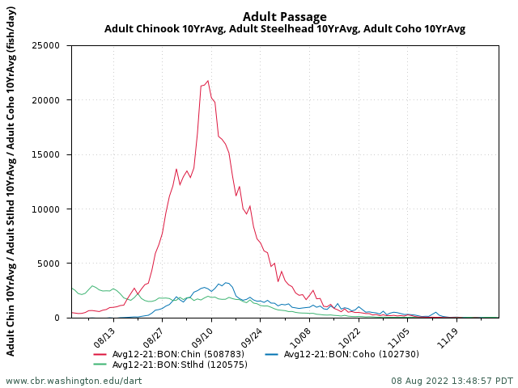

**Figure 1: 10 Year Average (2012-2021) Adult Daily Passage for Fall Chinook, Steelhead, and Coho between August – December.**

1. **Statement about the current year’s run (e.g., higher, or lower than 10-year average).**

**Run predictions obtained from WDFW**

|  |  |
| --- | --- |
| Fall Chinook | Slightly below average |
| Coho | Well above average |
| Steelhead | Well below average |

1. **Estimated exposure to impact by species and age class (i.e., number or percentage of run exposed to an impact by the action).**

Please see **Table 1** for adult impacts and percentage of run impacted. Figure 1 demonstrates the 10-year (2012-2021) average for adult daily passage at BON during the fall period. The planned inspection date is well after the peak run time for adult salmonids.

The work period does not coincide with any of the major juvenile salmonid out migrations. Subyearling Chinook are typically the latest run outmigration and 95% of the run has passed by 19 July (DART).

The impacts to adult lamprey are minimal as not many lampreys are passing Bonneville during this work period. Based on the 10-year average between 2012-2021, 95% of the adult lamprey run has passed by 23 August (retrieved from DART, 2022).

1. **Type of impact by species and age class (increased delay, exposure to predation, exposure to a route of higher injury/mortality rate, exposure to higher TDG, etc.).**

Adult salmonids are expected to be more attracted towards the fishway entrances at the priority powerhouses during the work period. All fish ladders will be available during this outage. The fish that are in the stilling basin during the inspection may have a harder time finding the fishway entrances due to lack of attraction flow, exposing them to a greater risk of sea lion predation.

Downstream migrants that would normally pass through the Spillway on 26 October will be delayed until the inspection is finished. This delay may increase the risk to predators. The Ice and Trash Sluiceway and Downstream Migrant Channel will remain open and available for downstream passage.

The Spillway outage will occur toward the end of the adult lamprey migration period. All ladder entrances and LPSs should be operating at the time of the spill bay outages. The loss of attraction flow provided by spill bays 1 and 18 will impact lamprey that would use this flow to find these ladder entrances. However, this impact to lamprey is small, as most adults have already passed Bonneville at this time.

**Summary statement - expected impacts on:**

**Downstream migrants** Very minimal. Historically, few juvenile salmonids migrate during this time. Those few that end up in the spillway forebay may be delayed and exposed to an increased risk of predation.

**Upstream migrants (including Bull Trout)** Minimal. All fish ladder entrances are available, and we expect most adult fish to be attracted to the priority powerhouse. For those fish that do end up in the stilling basin, sea lion predation is a possibility.

**Lamprey –** Very minimal. All Lamprey Passage Structures and fish ladders should be available during this Spillway outage. The lampreys in the stilling basin may be delayed at finding the fishway entrances, which increase their exposure to predation.

**Comments from agencies**

**Final coordination results**

Please email or call with questions or concerns.

Thank you,

**Steven Sachs**

USACE Portland District

Columbia River Coordinator (acting)

(971) 284-6422

[steven.a.sachs@usace.army.mil](mailto:steven.a.sachs@usace.army.mil)

**Andrew Derugin**

Supervisory Fish Biologist

Bonneville Lock & Dam

541-374-3879

[andrew.g.derugin@usace.army.mil](mailto:andrew.g.derugin@usace.army.mil?subject=22BON075%20MOC)